Assignment 2

1. The arrival delay tends to decrease overall as the week starts and ends, with a decrease towards the middle. Departure delays tend to occur at the beginning, Sunday, and Friday.

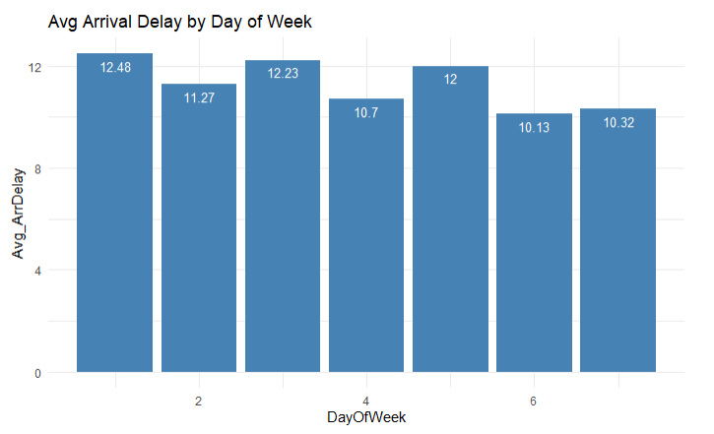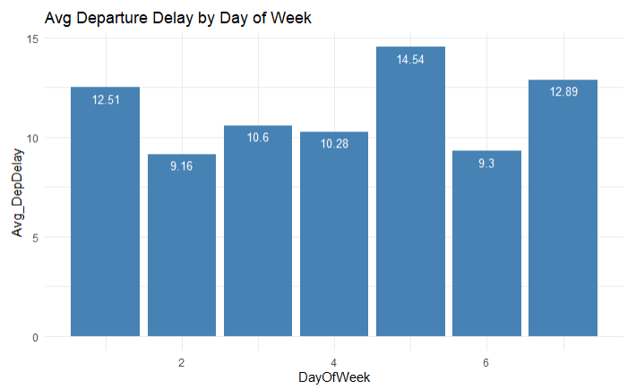

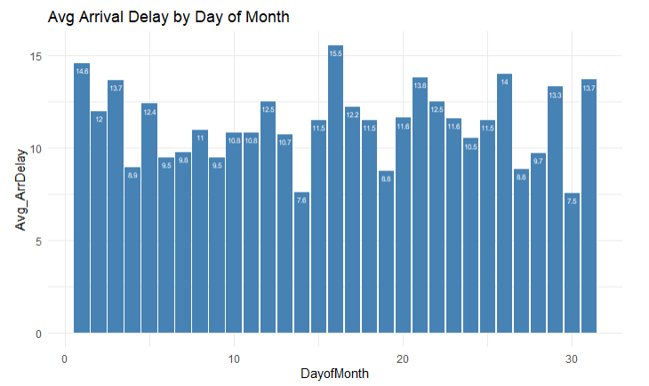

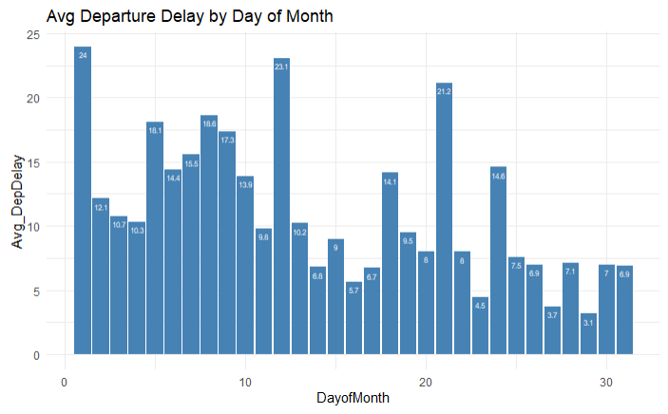

1. The results can be taken to mean that in the aggregate there are not too many differences between each parts of the week. However, there might be varying levels of capacity that can explain the slight variations by week and time of month.
2. Airport 12892

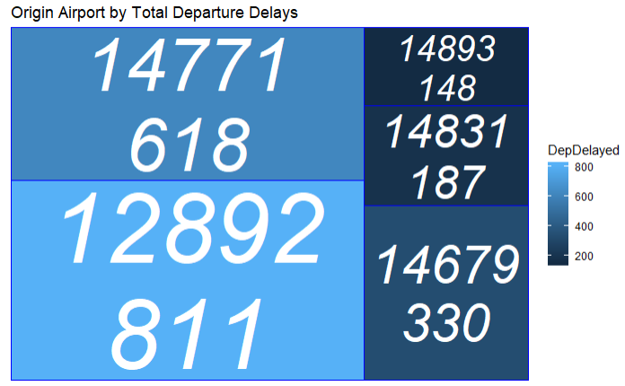

1. Airport 12892

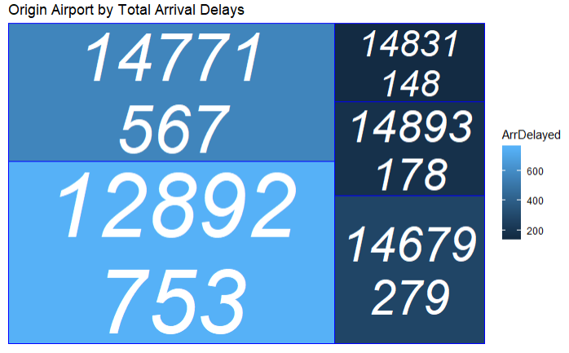

1. There appears to be a weak negative relationship.

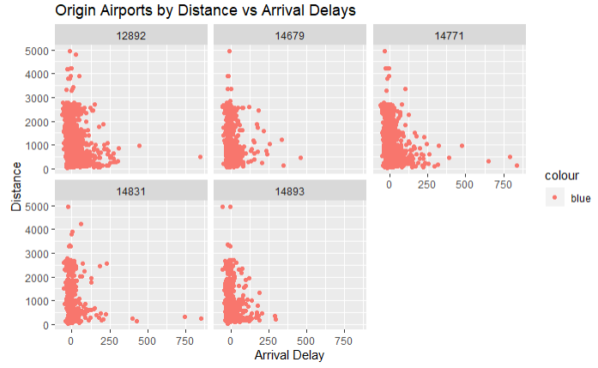

1. There is also a negative relationship.

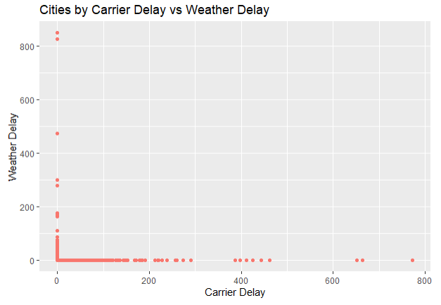Correlation: [1] -0.006126094

1. The pattern is more consistent when it comes to the South and West. The Northeast and Midwest are more volatile.

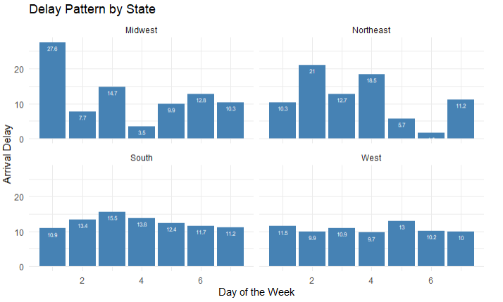

1. 44
2. 3
3. The delays tend to be most frequent starting from the beginning to end of day when they become less frequent.

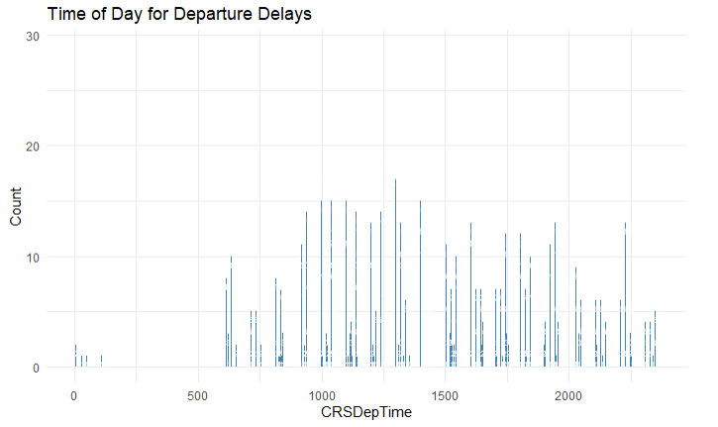

1. We see a similar pattern for arrivals. Delays start at the beginning and become more frequent as the day moves on, while falling towards the end of the day.

